
Story

Date | 28 October 2026
Team ID | To be filled by team
Project Name | Healthcare Risk Analysis Dashboard using Tableau
Maximum Marks | 5 Marks

By using stories in Tableau, you can effectively communicate complex data in a way that is both interactive and engaging, making it easier for the audience to follow along and understand the insights. It’s a tool for data storytelling, allowing you to present insights in a cohesive, engaging way that takes viewers through a logical progression of findings or analyses.
In Tableau, Story is a feature that allows you to create a sequence of dashboards, visualizations, and text to present data insights in a cohesive and narrative-driven way. It's like a slideshow within Tableau that guides the audience through a series of data points, helping them understand key insights, trends, or outcomes of your analysis.

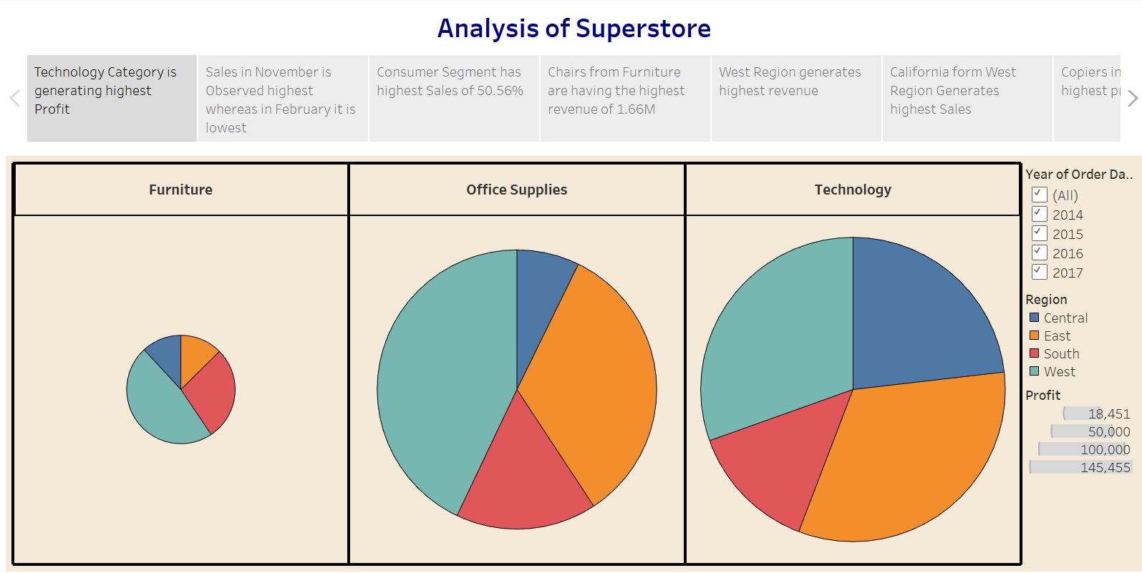

Observations:
- Technology Category Leads in Profit: The Technology category is generating the highest profit among all categories.
- Seasonal Sales Trend: Sales peak in November, while February sees the lowest sales, indicating a possible seasonal trend.
- Consumer Segment Dominates: The Consumer segment contributes to the highest percentage of sales, accounting for 50.56%.
- Top Revenue-Generating Product: Chairs from the Furniture category generate the highest revenue, totaling 1.66M.

Activity 2:
Publish Story on Tableau Public and Paste Public link below
https://public.tableau.com/views/SalesStory_17247663658720/Story1?:language=en-US&:sid=&:redirect=auth&:display_count=n&:origin=viz_share_link
Storyline: Exploring Chronic Disease Patterns
Use Tableau Story points to guide a reviewer from the overall dataset to demographic patterns, clinical indicators, lifestyle/symptom comparisons, and limitations.
Suggested story points
Story Point | View / Caption | Narrative
1. Dataset Overview | KPI cards: total records and positive disease labels | Introduce the 5,000-row dataset and explain that counts describe records in this file.
2. Demographic Patterns | Disease labels by age band and gender | Explore how recorded disease labels vary across demographic groups.
3. Clinical Indicators | BMI, blood pressure, cholesterol and glucose distributions | Compare distributions across labels; note unusual values and missingness checks.
4. Lifestyle Factors | Smoking, alcohol and exercise comparisons | Review patterns without claiming that these variables cause disease.
5. Symptoms | Fatigue, chest pain and dizziness compared with disease labels | Explore co-occurrence in the dataset and clarify that this is not a diagnostic rule.
6. Data Quality & Caveats | Data quality summary and risk-score warning | Explain that there are no missing cells or exact duplicate rows in the supplied file, while health_risk_score is constant at 100.0.
Observations to validate with the final charts
• Source file contains 5,000 records and 16 fields.
• Positive labels recorded: heart disease 1,499; diabetes 1,746; stroke 1,243.
• Dataset-level label counts can differ from unique-patient counts if one row is not guaranteed to equal one unique person; no patient ID is present in the listed fields.
• Do not state that age, lifestyle or symptoms cause a disease based only on these charts.
• health_risk_score is constant and cannot meaningfully separate records until verified.
Activity 2 — Tableau Public Story link
Paste the actual public story URL here after publishing. No URL has been created by this document.

